The Preston Model: A difference-in-differences analysis of a new economic framework

# Background

The city of Preston, prior to their implementation of Community Wealth Building (CWB) – the precise nature of which is now known as the Preston Model (Preston City Council, 2019) – suffered from a variety of detrimental health and economic problems.

## What Problems was Preston Experiencing?

In 2010, 2-3 years prior to the implementation of CWB, the median Lower layer Super Output Area (LSOA) (an LSOA is a collection of typically four or five Output Areas (OAs) which are the lowest level of geographical area for census statistics; an LSOA will typically contain 1,000-1,300 residents (Office for National Statistics, 2023)) in Preston ranked in the bottom 40% on the Index of Multiple Deprivation (IMD), as seen in figures 1 and 2.

|  |  |
| --- | --- |
| **Decile** | **UK 2010 IMD Distribution** |
| **1** | 5.77 |
| **2** | 8.49 |
| **3** | 10.99 |
| **4** | 13.79 |
| **5** | 17.25 |
| **6** | 21.35 |
| **7** | 26.77 |
| **8** | 34.17 |
| **9** | 44.88 |
| **10** | 87.80 |

*Figure 1 – Distribution of the UK’s Index of Multiple Deprivation scores as deciles, where a higher score indicates a higher level of relative depravation.*

|  |  |
| --- | --- |
| **Quartile** | **Preston 2010 IMD Distribution** |
| **Minimum** | 4.88 |
| **First Quartile** | 11.40 |
| **Median** | 25.42 |
| **Third Quartile** | 40.45 |
| **Maximum** | 75.04 |

*Figure 2 – Distribution of Preston’s Index of Multiple Deprivation scores as quartiles.*

Preston also had an unusually high rate of male suicidality, self-harm-related hospital admissions, eating disorders, etc., for its local area in 2012 (Lancashire JSNA, 2012, pp. 13, 24, 39). Its most deprived districts also featured in the bottom quintile nationally for child wellbeing (*ibid*, p. 58). While the city was already struggling with health issues, economic problems were further exacerbated when the £700mn Tithebarn regeneration project, proposed in 2005 and meant to bring investment and new jobs to the area, was scrapped in 2011 (Preston City Council, 2019). The local government decided to eschew the traditional economic development model and began to look towards Community Wealth Building to provide employment to ease poverty and other health issues.

## What is Community Wealth Building (CWB)?

Shortly after the Tithebarn project was scrapped, the Preston City Council began talks with the Centre for Local Economic Strategies to discuss how to bring Community Wealth Building to Preston.

CWB features what can mainly be described as ostensibly socialist, or social-democratic, principles being implemented in a top-down approach, with direction coming from the City Council which forms an “anchor network” with “anchor institutions” where all parties agree to uphold certain key values (Preston City Council, 2019, p. 8):

1. Paying a living wage,
2. Progressive procurement,
   1. Contracts awarded to firms should ideally be split up so as to be available to SMEs.
   2. Procurement should begin locally.
3. Considering not just the economic but also social value of employment, investments, and land use.

The term “anchor institution” refers to large-scale, local employers who are “often tied to a place by their mission, physical assets and local relationships.” (Preston City Council, 2019, p. 10) Examples can include local authorities, NHS trusts, or large local businesses (*ibid*, p.10). In a sentence, CWB aims to keep local wealth from leaving the city and maximise the social value of what that wealth can produce.

After an initial investigation in 2012, it was discovered that, of the £750mn spent by anchor institutions in Preston, only “5% of it was spent with organisations based in the Preston boundary, with 39% spent with organisations based in wider Lancashire.” (*ibid*, p.11) In total, over $458mn was leaving the Lancashire economy. By 2016/17, after the implementation of CWB by the Preston City Council and Lancashire City Council, locally retained spending in Preston increased to 18.2% and in Lancashire increased to 79.2% (*ibid*, p.11).

As of writing this paper, anchor networks have been established by multiple other city councils, including Birmingham, Oldham, Salford, Kirklees, Islington, Enfield, Southampton, Wakefield, Bristol (Preston City Council, 2019) and Leeds (Leeds City Council, n.d.).

## Has the Preston Model helped Preston?

Difference-in-differences analyses examining statistically significant differences in cities with and without CWB is minimal, with only a single paper, published in 2023 by Rose et al., examining the Preston Model using this kind of analysis. They found that Preston’s CWB has had statistically significant, positive effects on antidepressant prescriptions, depression diagnoses, life satisfaction scores, and median wages when compared to control cities. However, most of these parameters did not display statistically significant difference from the control pool in the final year of analysis, 2019, seen in figures 3 and 4.

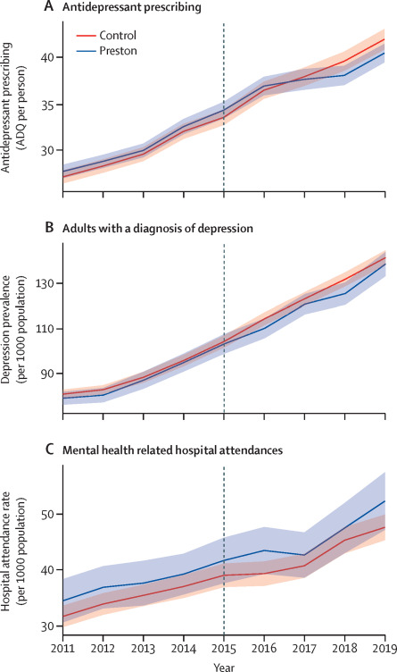

*Figure 3 (Rose, et al., 2023)*

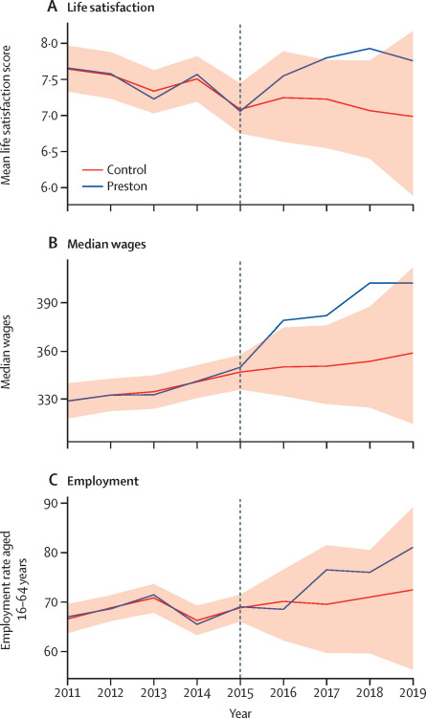

*Figure 4 (Rose, et al., 2023)*

Whyman (2021) has published literature justifying the theoretical economic foundations of the Preston model, arguing that, while CWB is protectionist in nature, not all protectionism is bad – CWB ostensibly falls in line with existing British values being pushed by Westminster, e.g., Whyman (2021, p. 137) argues that it should theoretically enhance competition, stamp out rent-seeking and move the market closer to the social optimum. Whyman (2021, p. 142) also suggests that the evidenced economic impacts CWB has had, namely the growth of the proportion of local procurement in Preston and Lancashire, should be indirectly corroborated by indirect evidence concerning factors such as “growth rates, employment opportunities and human capital investment.”

In essence, CWB is strongly associated with positive effect on median wages and life satisfaction in the short-term; however, effects on other important economic parameters, such as those laid out by Whyman (2021) remain largely unknown.

# Rationale

This broad ambiguity warrants investigation into CWB for a few key reasons.

First, as mentioned prior, the existing scope of research is narrow: such a self-admittedly large shift in not only the role of local government, but also local private institutions and businesses, ought to be carefully considered. As it stands, no potential negative effects that critics associate with CWB have been analysed, e.g., increased costs, reduced competition, rent-seeking, etc.

Second, the economic foundation but forward by Whyman (2021, p. 136) is self-admittedly heterodox. Even if, as Whyman (2021, p. 137) claims, the charge of local protectionism is “certainly not a straightforward conclusion to reach,” the fact remains that local firms, given special priority over distant firms by virtue of their geographic location, collect economic rent (Fried & Bebchuk, 2004, p. 62). Mainstream economic theory suggests that rent-seeking behaviour inhibits growth and innovation while increasing prices due to a misallocation of resources (Dabla-Norris & Wade, 2001; Murphy, Shleifer, & Vishny, 1993). This fact, coupled with the contentious view of economic foundation of the Preston Model (The Economist, 2017) indicates further investigation is needed to measure the veracity of Whyman’s (2021) theoretical foundations.

Third, data from the UK government suggests that the median LSOA in Preston’s multiple depravation index has increased since 2015, shown in figure 5.

*Figure 5, Source: Own Illustration, data:* (UK Government, 2019; UK Government, 2015; UK Government, 2011)

This is particularly relevant considering decreasing poverty was one of the Preston Model’s chief priorities (Preston City Council, 2019, p. 7). Research is needed to compare this trend to control cities and determine if CWB has had any statistically significant effect on poverty levels.

Finally, incorrectly assessing the long-term viability and effects of CWB could result in wasted tax-payer money. If CWB produces no statistically significant, long-term improvements in the local economy, employment or health, many councils who have adopted CWB principles may paying for economic rents rather than investing in alternatives which could have offered a better chance at alleviating hardships.

# Methodology

## Parameters

The parameters I will be analysing to observe a statistically significant difference between Preston and the control group are:

* Index of Multiple Depravation (IMD)
* GDP per capita
* Rent as a proportion of GDP
* UK Competitiveness Index
* Council expenditure

## Collecting and calculation

The IMD, GDP per capita, and UK competitiveness index will require very little calculation, as these figures are easily available and accessible in terms of local authorities (UK Government, 2011; Office of National Statistics, 2024; Centre for International Competitiveness). Collecting council expenditure information is also trivial – it involves procuring the statement of accounts for Preston and each control city, for each of the years being analysed. This is publicly available information which every local authority must publish (Local Government Association, 2024).

I will employ the methodology laid out by Stemerding (2023) to calculate each city’s (Preston’s and the controls’) rent as a proportion of GDP. Stemerding’s (2023) method uses surplus cash flow as a proxy for rent. To describe the method formally, surplus cash flow (SCF) is the difference between your actual return on investment and the normal return on investment, i.e.

To calculate the normal return on investment (nROI) for a whole city, Stemerding (2023, p. 8) utilises the Capital Asset Pricing Model (CAPM), introducing *,* i.e., how strongly a firm’s returns correlate with the business cycle, and introducing the risk-free rate (RFR), i.e., the safest return on investment: typically a 10-year government bond (Stemerding, 2023, p. 8). The nROI is simply:

I have collected all of the variables necessary and corresponding data sources in figure 6.

|  |  |  |
| --- | --- | --- |
| *Variable* | *Calculation* | *Source* |
|  | Gross Value Added – Total Employee Compensation | (Office of National Statistics, 2024; Office for National Statistics, 2018) |
|  | Equivalent to fixed capital formation (FCF) (Stemerding, 2023, p. 8) | (Office for National Statistics, 2023) |
|  | A list of the top 5 biggest industries in a city will be compiled, and those industries’ will be found by matching with a list of known industry s. A weighted average will then be calculated. | (PwC, 2009; Lancashire City Council) |
|  | This is the investment multiplied by a ten-year bond yield. | (Trading Economics, 2024) |
|  | Gross Operating Surplus - Investment | *Already stated.* |
|  | SCF divided by Gross Value Added | *Already stated.* |

## Difference-in-differences method

## Synthetic control method

I’ll be using data provided

Difference-in-differences study similar to the Rose et al. 2023 paper.

* How will similar cities be found?
* Propensity score measuring (Stuart et al. 2014)
* How has the proportion of funds spend locally changed since 2015?
* What parameters?
  + Index of multiple depravation
  + Local GDP
  + Competitiveness
  + Employment

## Analysis

* Look at equation
  + Explain each parameter
* What will the results mean?
  + Insignificant effects will mean that local councils should take another look at CWB
  + Seeing how local procurement has actually changed will be illuminating
    - If it hasn’t increased too heavily, accusations of protectionism will be less relevant as the only agents possibly incurring higher costs are private institutions.